|  |  |
| --- | --- |
| CCDP2100U_W18-A3_T2 - PowerPoint    Hydraulic House  Trompe Use  Project Proposal  CCDP 2100U W18 T2 | **Fareen Lavji**  Sian Smith  Reid Paxton  Christopher Canton  Thomas Da Silva  Date Submitted: February 28, 2018  Instructor: Ricardo Tabone  Peer Mentor: Narmada Samdandam |

Contents

[Figures 1](#_Toc507626836)

[1 Introduction 2](#_Toc507626837)

[1.1 Purpose 2](#_Toc507626838)

[1.2 Utility 2](#_Toc507626839)

[1.3 Novelty 2](#_Toc507626840)

[1.4 Ingenuity 2](#_Toc507626841)

[2 Background 2](#_Toc507626842)

[3 Project Description 3](#_Toc507626843)

[3.1 General Project 3](#_Toc507626844)

[3.2 Personal Research 3](#_Toc507626845)

[3.2.1 Principle 4](#_Toc507626846)

[3.2.2 Trompe function 4](#_Toc507626847)

[4 Conclusion 5](#_Toc507626848)

[5 Glossary 6](#_Toc507626849)

[6 References 7](#_Toc507626850)

[7 Appendices 8](#_Toc507626851)

[7.1 Appendix A: Research Table 8](#_Toc507626852)

[7.2 Appendix B: Project Timeline 8](#_Toc507626853)

[7.3 Appendix C: Team Contract 8](#_Toc507626854)

# Figures

[Figure 1: Hydraulic Home Model 3](#_Toc507626637)

[Figure 2: Elastomeric Pad Bearings 3](#_Toc507626638)

[Figure 3: Basic Trompe System 4](#_Toc507626639)

[Figure 4: Simplified Venturi Effect 4](#_Toc507626640)

# Introduction

## Purpose

On January 8th of 2018, Instructor Ricardo Tabone requested a project where assigned teams would work on reverse engineering or designing a new product that would serve as a benefit to the industry or layman. As such, Team 2 decided to create a safety mechanism in the event of excess flooding or hurricanes called the [Hydraulic](#Hydraulic) House.

## Utility

The way the Hydraulic House works is that it uses a hydraulic pipe system, fitted in with the [foundation](#Foundation) to raise a home above the flood water’s level thereby protecting the inside from damage that the water can bring. In addition, it uses special bearings that create additional support while the house moves in a vertical position.

## Novelty

This system is quite unique in the fact that it, as mentioned above, raises an entire home from its foundation. Not only that, but it does so proportional to the level of flood water. This is due to the Trompe it uses which creates power relative to the amount of flood water it “ingests.”

## Ingenuity

The genius attribute about this product is that the power it sources can be used for other purposes when the area is not stricken with disasters. This is because the compressed air it creates is stored in a cistern that can be lead to other locations in the house for mechanical use, thereby reducing consumption of other fuel resources.

# Background

Members of Team 2 had a brief discussion and found that there is no safety mechanism existing for preventing heavy rains or hurricanes from flooding houses. Hurricane Maria reported a death toll of 62 while a supposed actual being 1052 [1]. This is just a small glimpse of deaths reported from the 2017 Atlantic Hurricane Season that swept across the Caribbean and onto the coastal U.S. [2] and so many more that the world has seen from centuries of water borne natural disasters. In addition, it has been reported that global precipitation rates have been increasing annually by drastic amounts. When looking at it from a financial perspective, floods can cost over $5000 dollars depending on how deep the flood water is and direct flood damages in the 2014 Water Year totalled approximately $3 Billion dollars.

If it were possible to raise homes from disastrous floods, not only would we be reducing costs in the long run but, it would ensure ground safety and in worse events, more time for air evacuation. To achieve this goal, we designed this relatively simple system that uses a lot of old age technology that is naturally eco-friendly and viable to produce as further explained.

# Project Description

## General Project

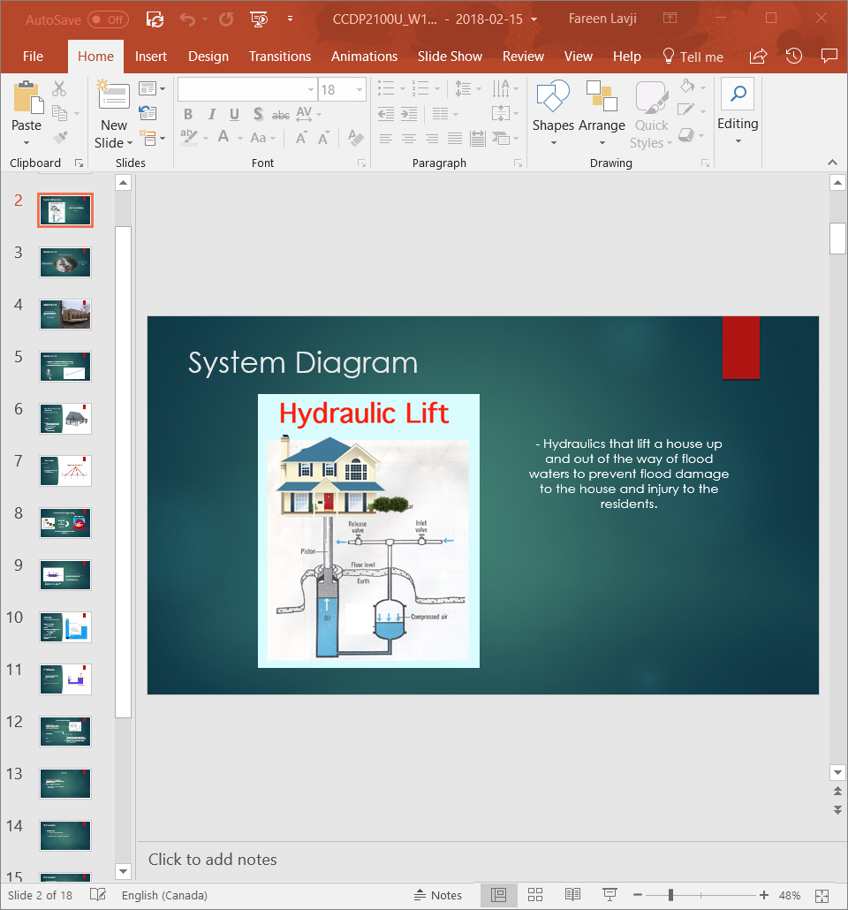

Figure 1: Hydraulic Home Model

As can be observed in the above figure, the Hydraulic House is a relatively simple structure that uses compressed air to push the [pistons](#Piston) of the hydraulics thereby raising the home off its foundation. To keep the home intact while it raises, it needs [Elastomeric Pad Bearings](#EPB) that are used in Bridges. These bearings can support vertical pressure and allow horizontal movements while holding the structure together. Another feature that we intend to implement into the Hydraulic House is a flood detection system that runs with the help of a [capacitor](#Capacitor). This flood detection system allows for additional preparation in the event of a flood, including evacuation precautions.

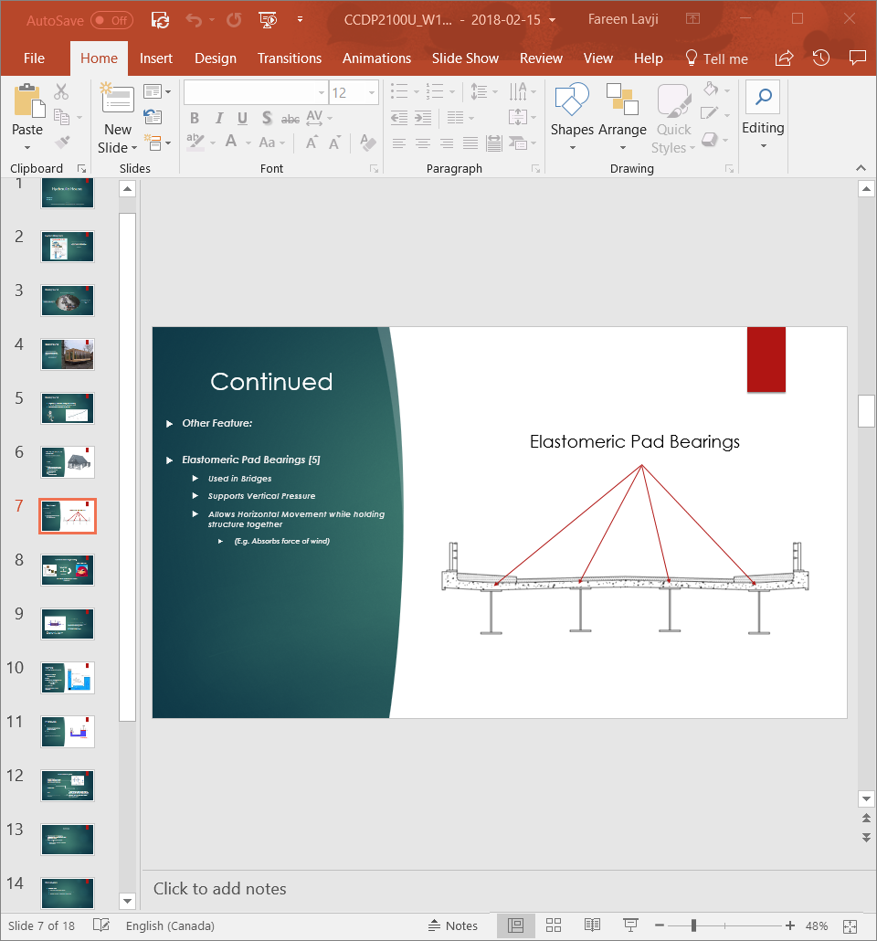

Figure 2: Elastomeric Pad Bearings

## Personal Research

As can be observed from Appendix A in another file [(CCDP2100U\_W18\_A2\_T2-A2F-A.docx)](https://cmailcarletonca-my.sharepoint.com/:w:/r/personal/ricardotabone_cunet_carleton_ca/Documents/CCDP2100U-W18/Work_Folders/T2/T2-Fareen_Lavji/A2-Final/CCDP2100U_W18_A2_T2_A2F-A.docx?d=w24f7d86cab434f759f7dc4d655c5deb4&csf=1&e=KwrdGM), I worked on creating a system that uses the flood water to run the Hydraulic System. This challenge was embarked on because in the event of a flood or hurricane, chances of electricity functioning are low and can be dangerous. Creating a system that uses the floods destructive property to run the mechanism also creates a more [sustainable](#Sustainable) system.

### Principle

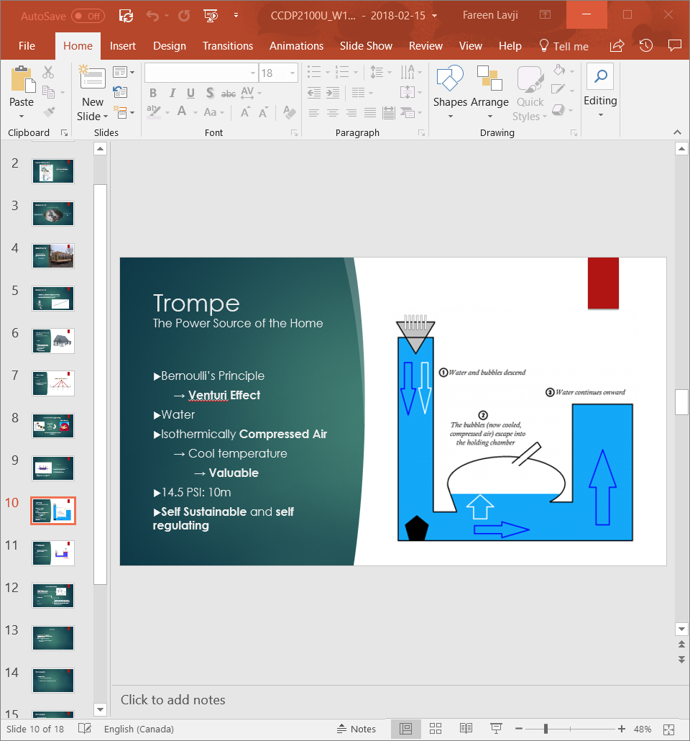

Figure 3: Basic Trompe System

To tackle this problem, I decided to implement a Trompe which is quite a simple device as described in the figure above. The way it works is through an extension of Bernoulli’s Principle known as the Venturi Effect where the velocity of water increases if it travels through a constricted pipe. This is because water is incompressible, and the flow rate of water cannot change [3]. This increase in velocity reduces the pressure which creates a suction.

[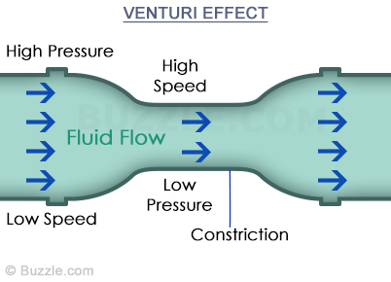](https://www.google.ca/url?sa=i&rct=j&q=&esrc=s&source=images&cd=&cad=rja&uact=8&ved=2ahUKEwjg57GVnMrZAhXp5IMKHfQOBdcQjRx6BAgAEAY&url=https://sciencestruck.com/explanation-applications-of-venturi-effect&psig=AOvVaw3A-gkr0JaZvdx-lFyh7HP3&ust=1519962615137387)

Figure 4: Simplified Venturi Effect

### Trompe function

This suction forms the basis of the Trompe through the entrance. Picture a whirlpool, the entrance of a Trompe forms the same concept; a water-borne suction cup that intakes bubbles of air along with it through a pipe. These air bubbles separate from the water in a big chamber before the water escapes through an outtake pipe [4].

The resulting air compresses without any raise in temperature ([Isothermically compressed air](#ICA)) which is a great bonus as it doesn’t raise the temperature of machinery that uses it. It is very valuable due to its power and can serve other purposes to create a sustainable home; a 10-meter length pipe alone can create 14.5 PSI of pressure [5] which is a little more than the recommended pressure of an American NFL Football. This compressed air can then be transferred to the hydraulic system through a mechanically automated [valve](#Valve), thereby raising the home from its foundation.

# Conclusion

By molding the destructive properties of natural disasters, we can effectively create a power system that not only increases safety in a home, but also has potential to source the compressed air for other household purposes. In effect, not only are we creating a safer future for residents of hurricane prone areas, but we are also doing so through an expandable, sustainable and eco – conscious approach.

We hope that the instructor accepts this Proposal and permits us to move forward with the research and tests required to expand upon this idea. In doing so, we are moving a step forward in our progressively, environmentally – conscious world through science and engineering.

Any questions or feedback can be forwarded to my contact information given below: -

eMail: [fareenlavji@cmail.carleton.ca](mailto:fareenlavji@cmail.carleton.ca)

# Glossary

|  |  |
| --- | --- |
| Hydraulic | Mechanical system that uses pressurized liquids in pipes to move objects |
| Foundation | The lowest load – bearing part of a building, typically below ground level |
| Piston | A disk fitted closely with a tube that can move up and down against a liquid or gas |
| Elastomeric Pad Bearing | A bearing commonly used in bridges [6] |
| Capacitor | A device consisting of at least one pair of conductors separated by an insulator that store stores an electric charge |
| Sustainable | A system that can maintain at specified levels |
| Isothermically Compressed Air | Air that is compressed without raising its temperature |
| Valve | A device that controls the passage of fluids |
|  |  |

# References

|  |  |
| --- | --- |
| [1] | F. Robles, "Nytimes.com," 09 December 2017. [Online]. Available: https://www.nytimes.com/interactive/2017/12/08/us/puerto-rico-hurricane-maria-death-toll.html.. [Accessed 2018 January 2018]. |
| [2] | Wikipedia, "Atlantic Hurricane Season," Wikimedia Foundations, Inc, 01 February 2018. [Online]. Available: https://en.wikipedia.org/wiki/2017\_Atlantic\_hurricane\_season. [Accessed 01 February 2018]. |
| [3] | Wikipedia, "Venturi Effect," Wikimedia Foundations, Inc, 13 January 2018. [Online]. Available: https://en.wikipedia.org/wiki/Venturi\_effect. [Accessed 28 February 2018]. |
| [4] | P. P. B. R. Levitt, "Aeration of Mine Water Using a Trompe," 2011. [Online]. Available: https://wvmdtaskforce.files.wordpress.com/2016/01/11-leavitt.doc. [Accessed 12 February 2018]. |
| [5] | E. Davis, "Science of the Trompe," Lost Technology, 19 August 2017. [Online]. Available: https://losttechnology.org/science-of-the-trompe/. [Accessed 12 February 2018]. |
| [6] | Wikipedia, "Elastomeric Bridge Bearing," Wikimedia Foundations, Inc, 28 April 2017. [Online]. Available: https://en.wikipedia.org/wiki/Elastomeric\_bridge\_bearing. [Accessed 28 February 2018]. |
| [7] | F. (. Sorge and G. (. Genchi, "Engineering Analyses," in *Essays on the History of Mechanical Engineering*, Springer, 2015, pp. 321-324. |

# Appendices

## Appendix A: Research Table

Submitted as a separate file[[Research\_v1]](https://1drv.ms/w/s!AtuX4REtPyo-wV2L_Gb6Dv_X1i-F)

## Appendix B: Project Timeline

Submitted as a separate file[[Timeline\_v1]](https://1drv.ms/x/s!AtuX4REtPyo-wVvjw82Acutagwnm)

## Appendix C: Team Contract

Submitted as a separate file[[Contract\_Final]](https://1drv.ms/w/s!AtuX4REtPyo-wVwe1Cck7VD9QObE)